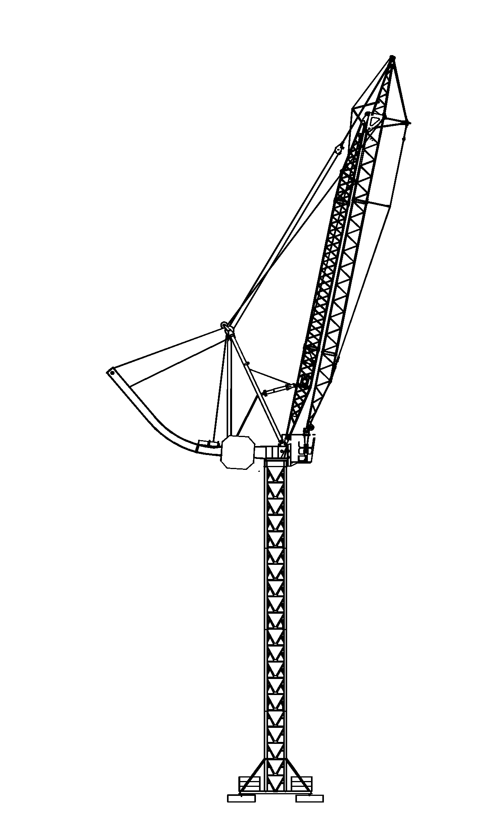
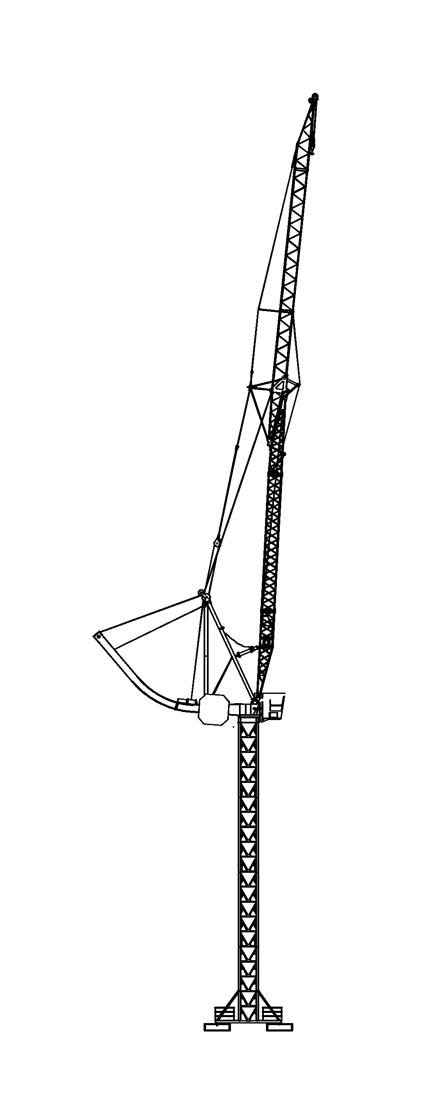
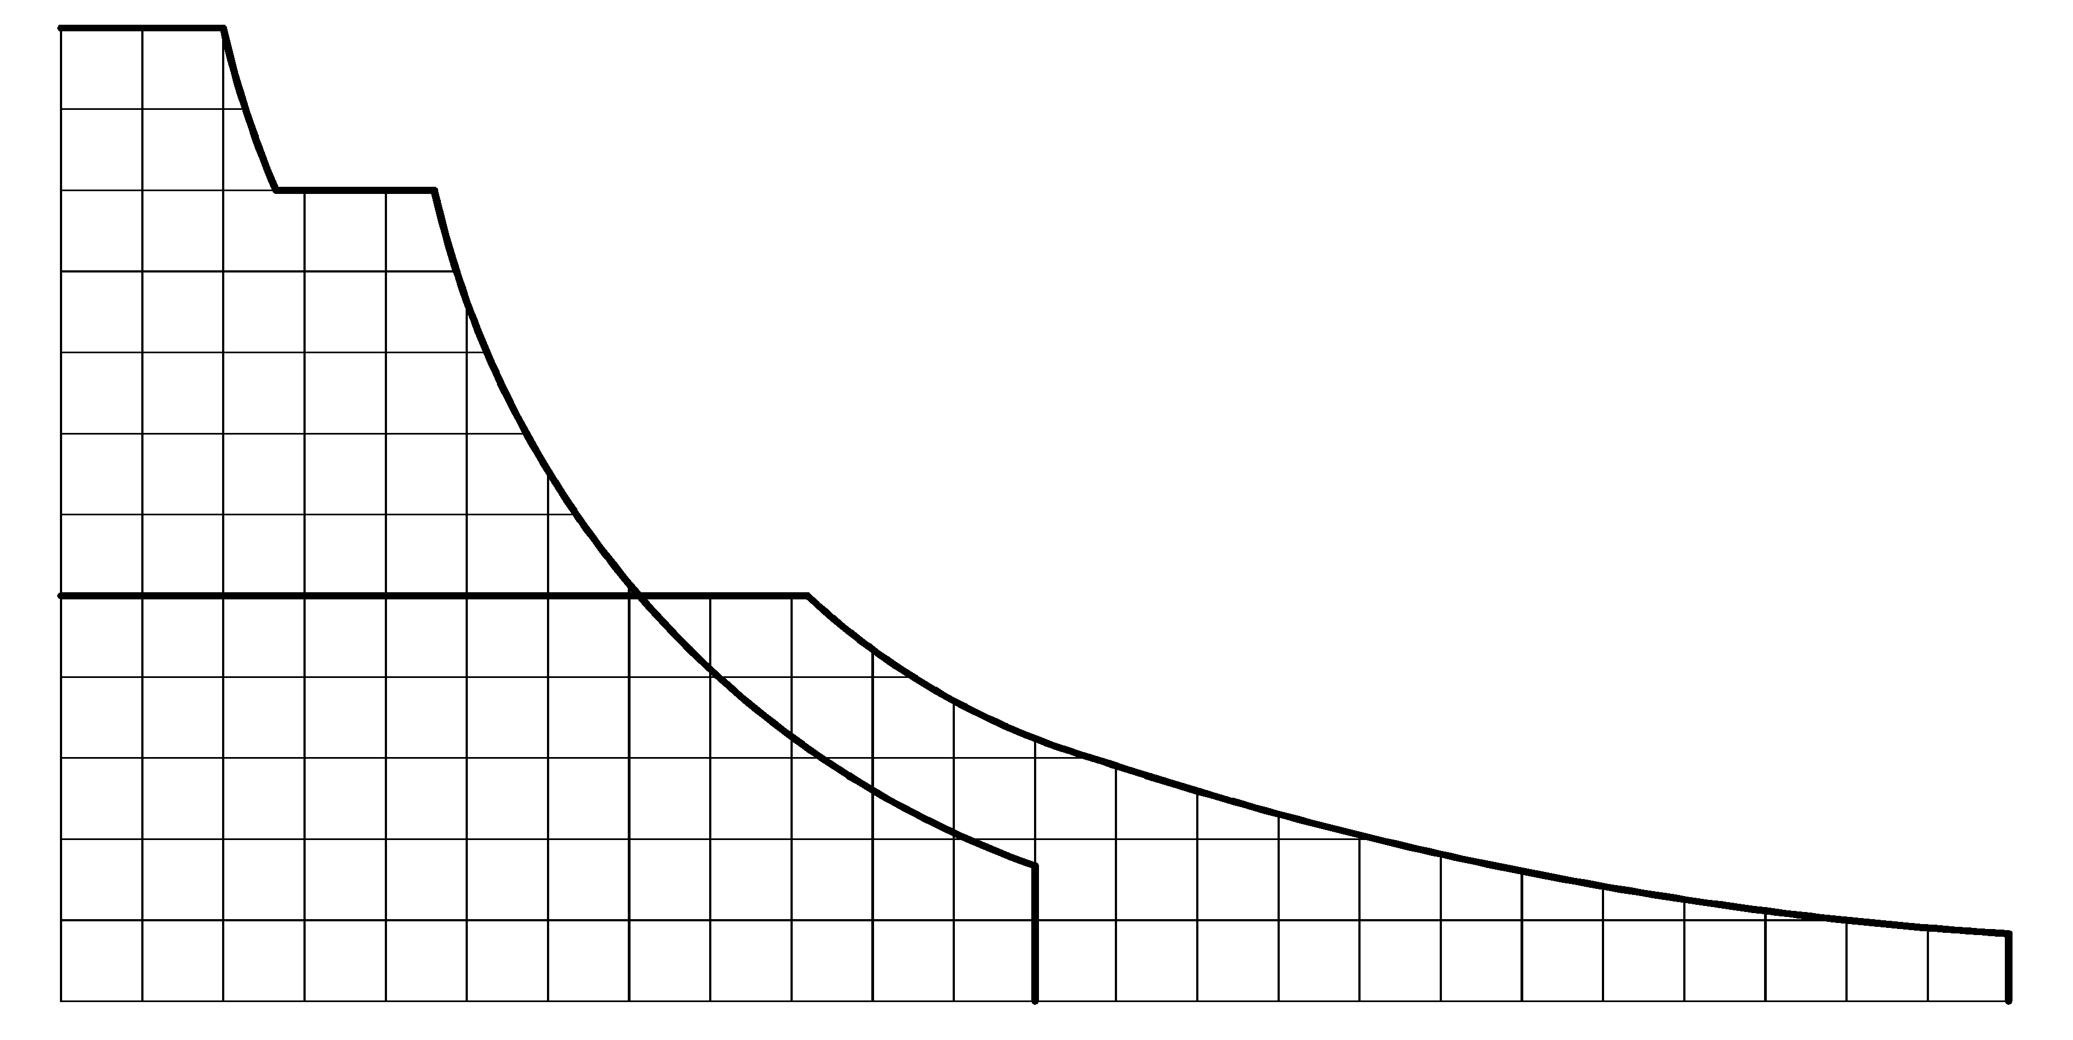
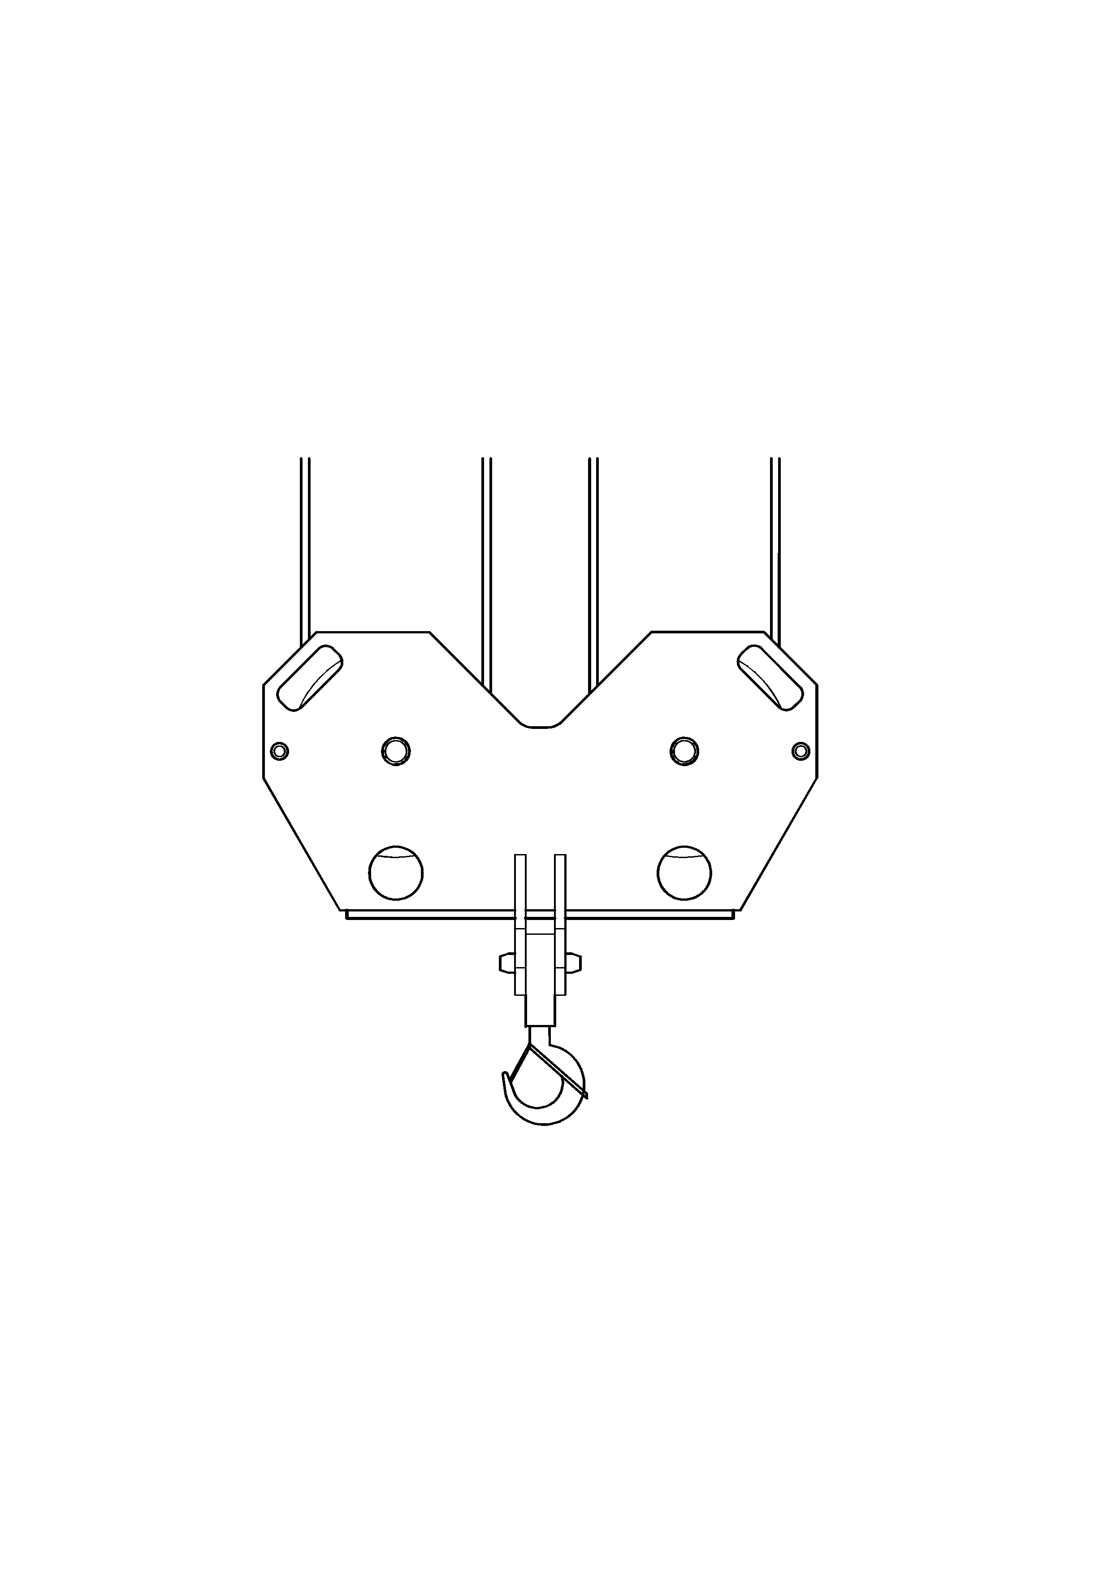
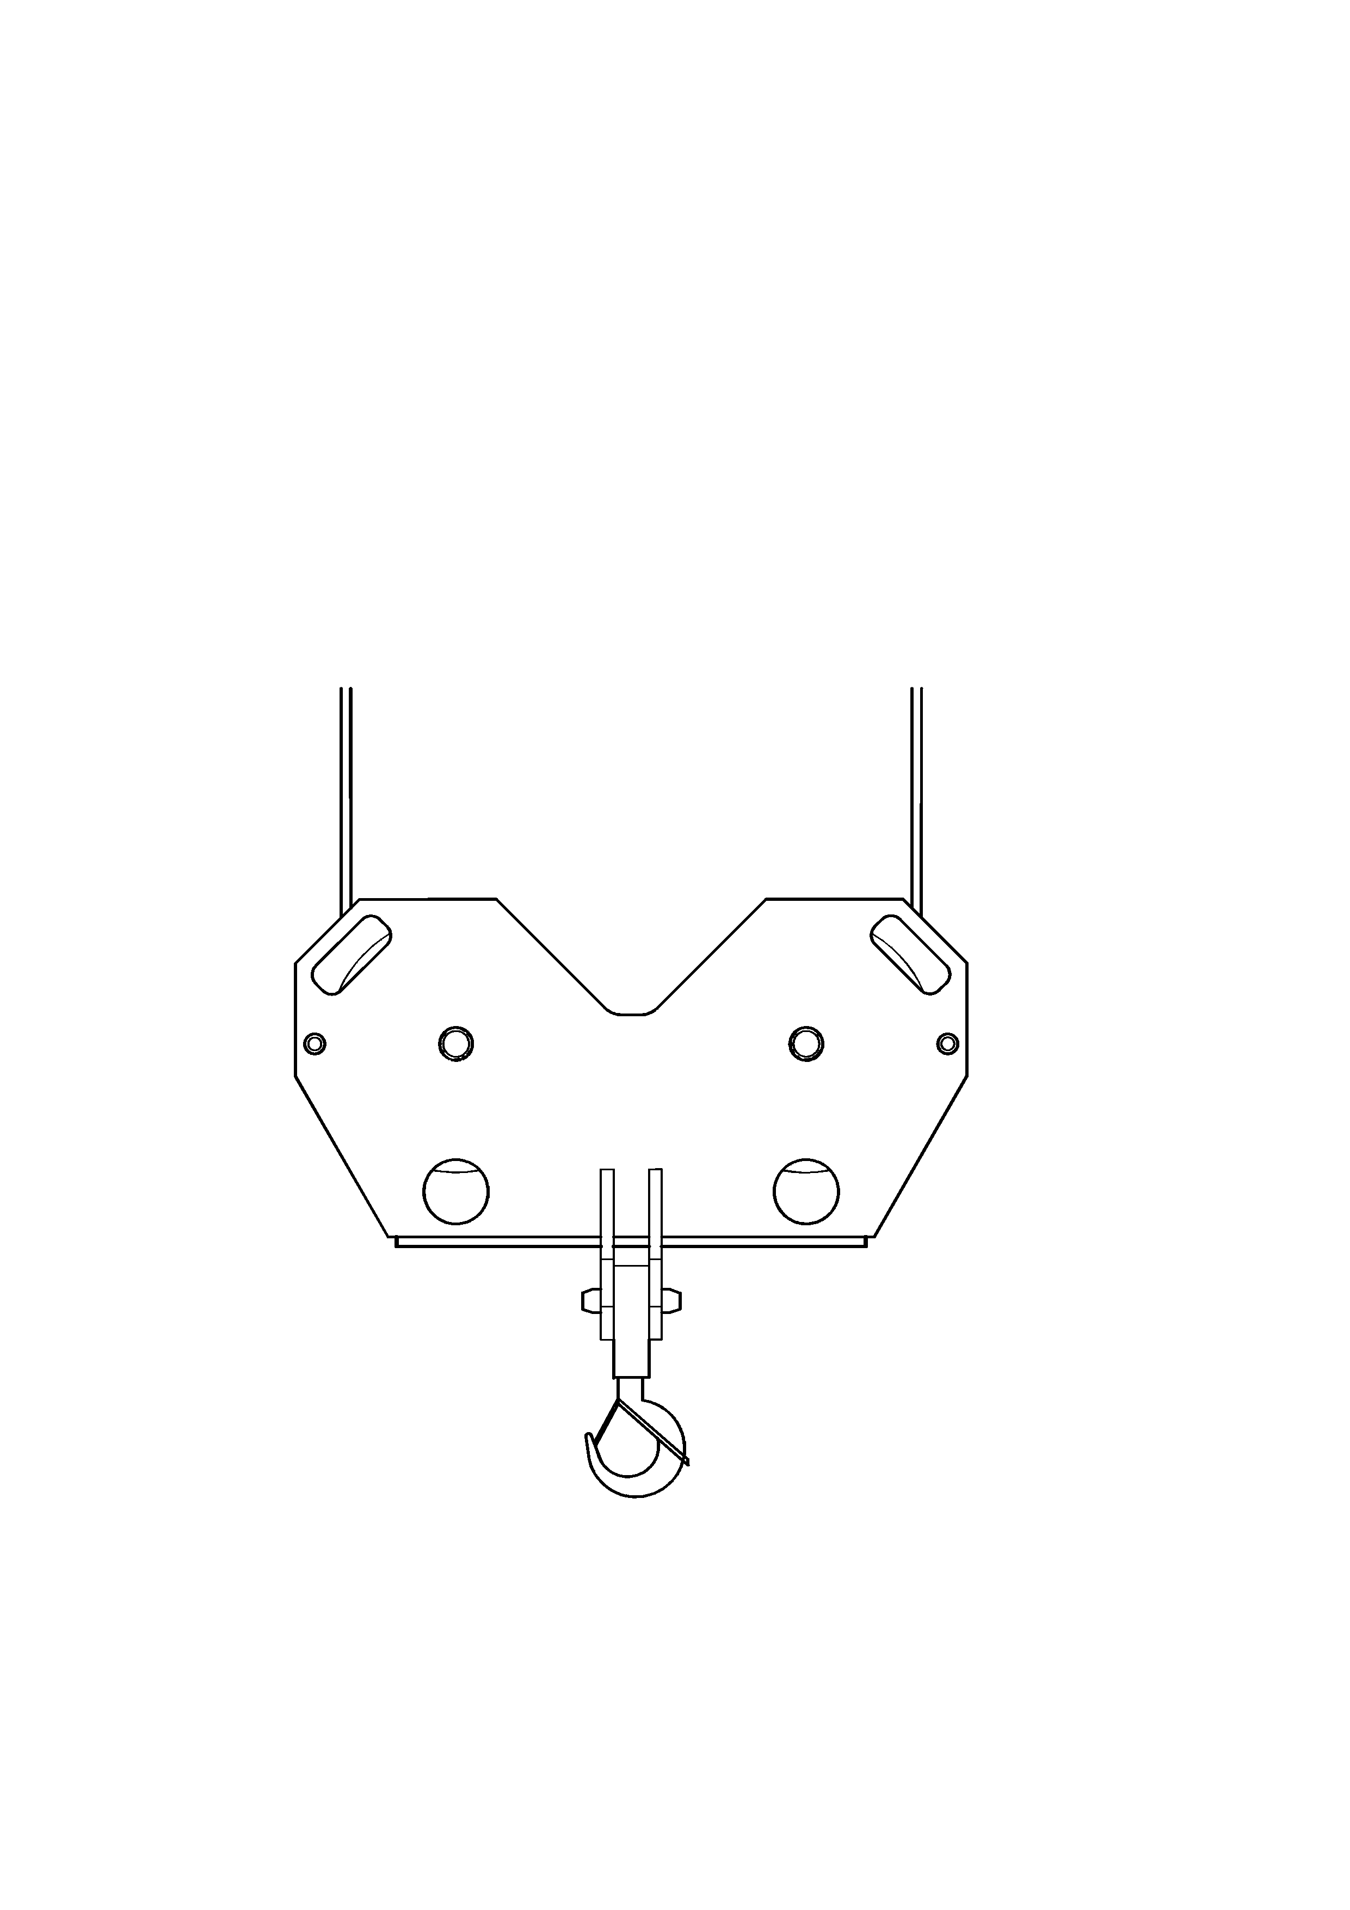
Mécanismes |  |  |  |  | Antriebe |  |  |  |  | Mechanismus
Distribution  Verteilung  Distribuation | Relevage*  Armheben*  Jib hoisting* |  | Rotation  Schwenken  Slewing |  |  |  | Heben |  |  |  |  | Hoisting
0-100 m/min | 0-17 m/min |  | 0-1.5 tr/min
0-100 m/min |  |  | 0-1.5 tr/min | 45 kW |  | Puissance requise  Anschlusswert  Power requirement |  |  | 94 kVA 135 A |  |  |  | 400 V – 50 Hz
(2) 7.5 kW | 22 kW |  | 7.5 kW |  |  |  |  |  | 115 kVA 165 A*
Grue à tour à flèche articulée et relevable*
Turmdrehkran mit Knick- und Wippausleger*
Tower Crane with articulated and liftable jib*

Cobra 538
Patent pending
Levage
40
20
60
80
1000
120
m/min
2
4
6
8
10
t
12

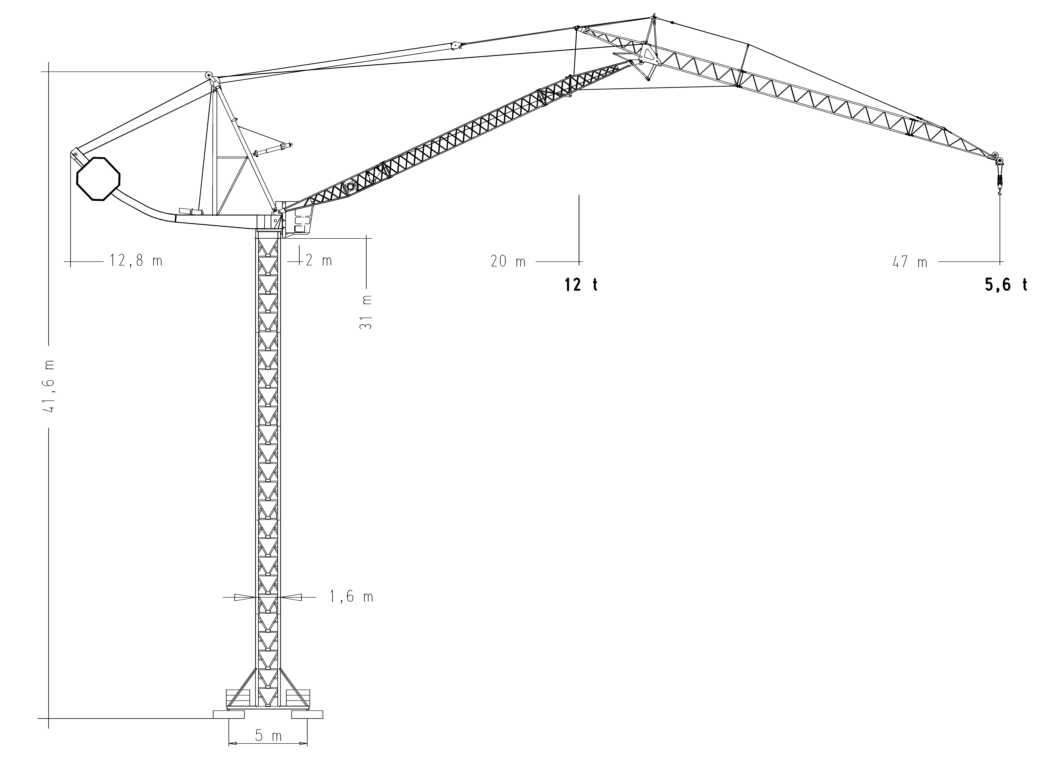
* En option / Option / Option

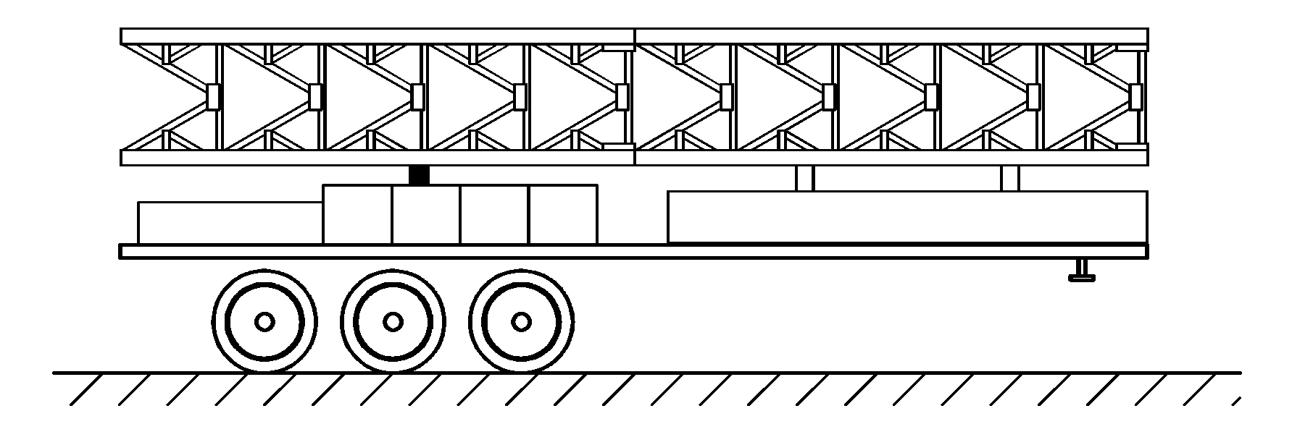
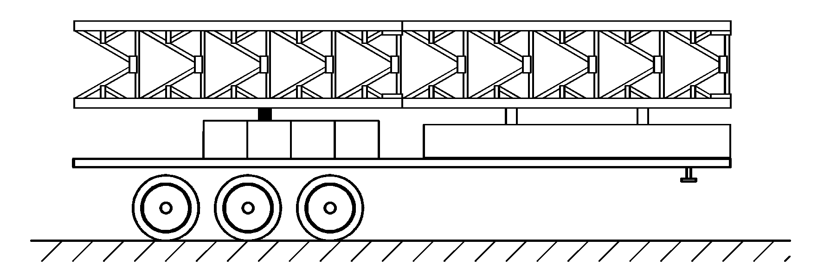
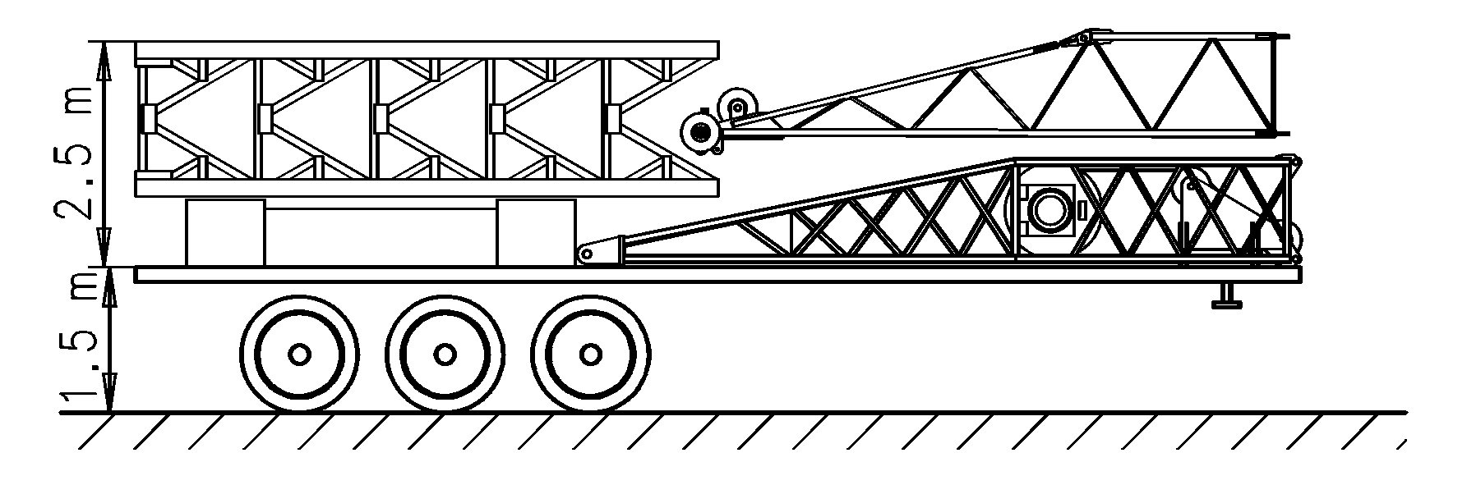
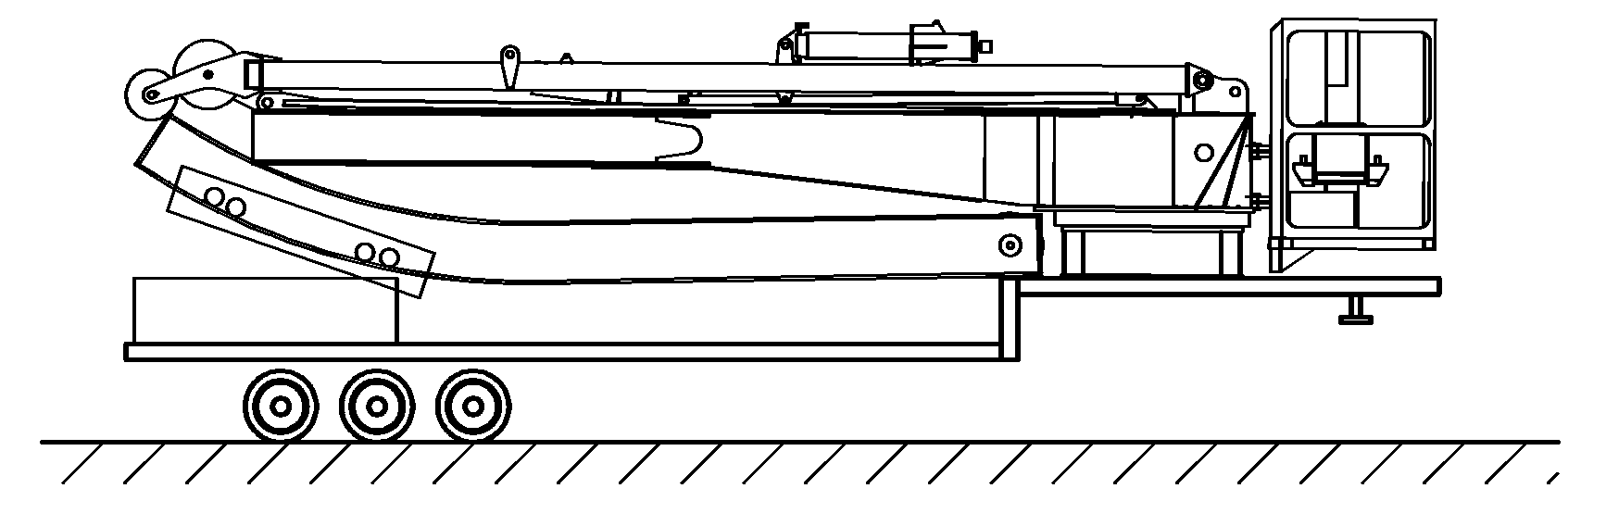
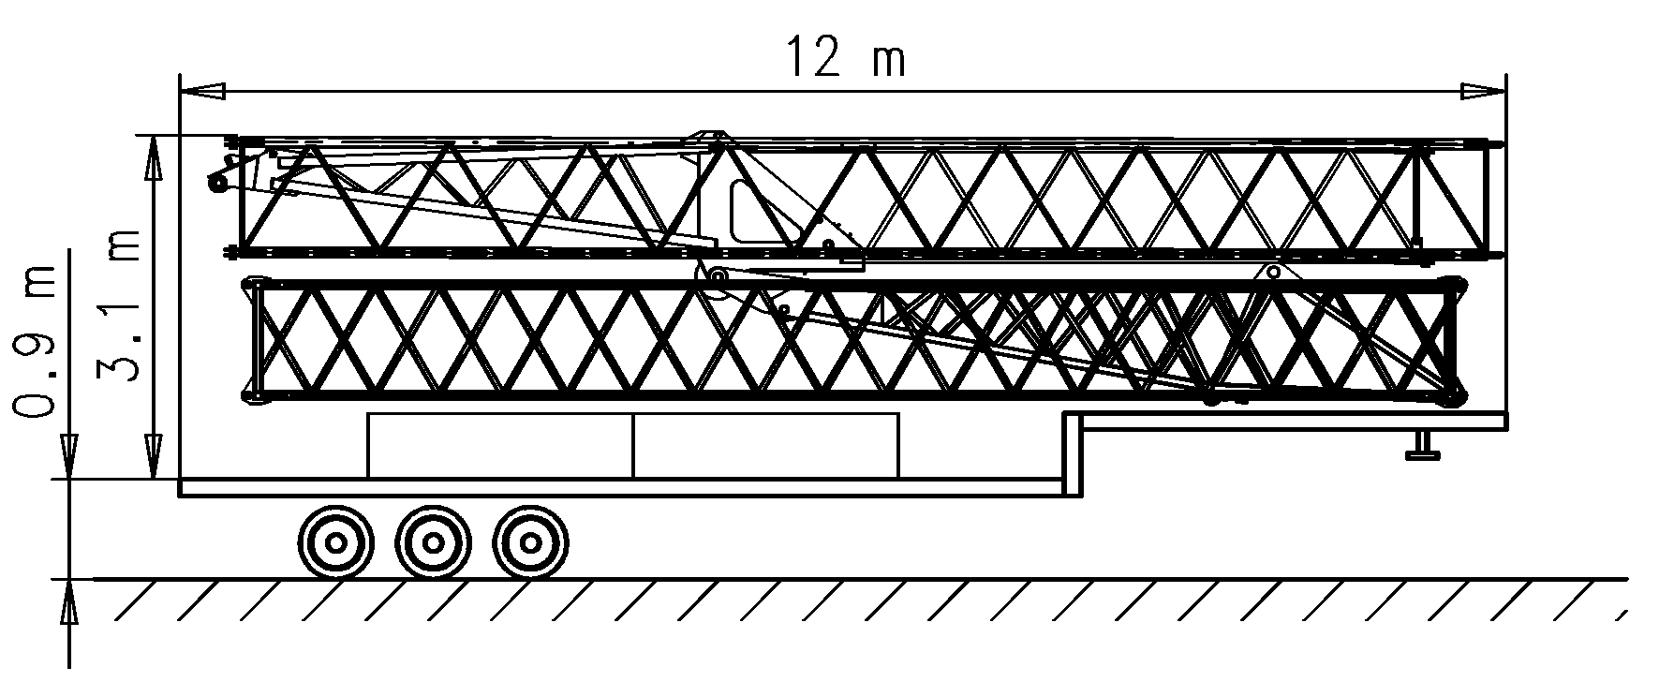
Transport |  |  |  | Transport |  |  |  |  |  | Transport

Hauteur sous cabine / Kabinenhöhe / Height under cabin 31 m

Châssis de base / Unterwagen / Basic chassis 5x5
 |  |  |  |  |  | Pos. | Qte. | L(m) | B(m) |  | H(m) | t
 |  |  |  |  |  | 6 | 2 | 6.00 | 1.60 |  | 1.60 | 2 x 2.58
 |  |  |  |  |  | 7 | 1 | 5.60 | 2.16 |  | 0.50 | 0.40
 |  |  |  |  |  | 8 | 1 | 2.40 | 2.16 |  | 0.50 | 0.75
 |  |  |  |  |  | 10 | 4 | 2.40 | 0.80 |  | 0.70 | 4 x 4.66
 |  |  |  |  |  |  |  |  |  |  |  | 24.95
 |  |  |  |  |  | 6 | 2 | 6.00 | 1.60 |  | 1.60 | 2 x 2.58
 |  |  |  |  |  | 7 | 1 | 5.60 | 2.16 |  | 0.50 | 0.40
 |  |  |  |  |  | 10 | 4 | 2.40 | 0.80 |  | 0.70 | 4 x 4.66
 |  |  |  |  |  |  |  |  |  |  |  | 24.20
 |  |  |  |  |  | 1 | 1 | 7.45 | 2.03 |  | 2.44 | 4.60
 |  |  |  |  |  | 6 | 1 | 6.00 | 1.60 |  | 1.60 | 2.58
 |  |  |  |  |  | 9 | 2 | 2.40 | 2.40 |  | 0.60 | 6.50
 |  |  |  |  |  | 10 | 2 | 2.40 | 0.80 |  | 0.70 | 2 x 4.66
 |  |  |  |  |  |  |  |  |  |  |  | 22.92
 |  |  |  |  |  | 4 | 1 | 11.98 | 2.45 |  | 2.37 | 12.20
 |  |  |  |  |  | 5 | 1 | 8.78 | 2.22 |  | 1.74 | 4.50
 |  |  |  |  |  | 9 | 2 | 2.40 | 2.40 |  | 0.60 | 6.50
 |  |  |  |  |  |  |  |  |  |  |  | 23.20
 |  |  |  |  |  | 2 | 1 | 11.50 | 1.10 |  | 2.39 | 2.20
 |  |  |  |  |  | 3 | 1 | 11.36 | 1.40 |  | 2.48 | 4.10
 |  |  |  |  |  | 9 | 2 | 2.40 | 2.40 |  | 0.60 | 2 x 6.50
 |  |  |  |  |  |  |  |  |  |  |  | 19.30
Poids total |  |  |  |  | Totalgewicht |  |  |  | Total weight |  |  | 114.50 t
1
2
3
4
5
7
10
6
8
6
7
10
10
1
6
9
4
9
5
2
3
9

50 m
2 m
20 m
12,8 m
12 t
4.5 t
31 m

41,6 m
ϲε FEM 1.001-A3

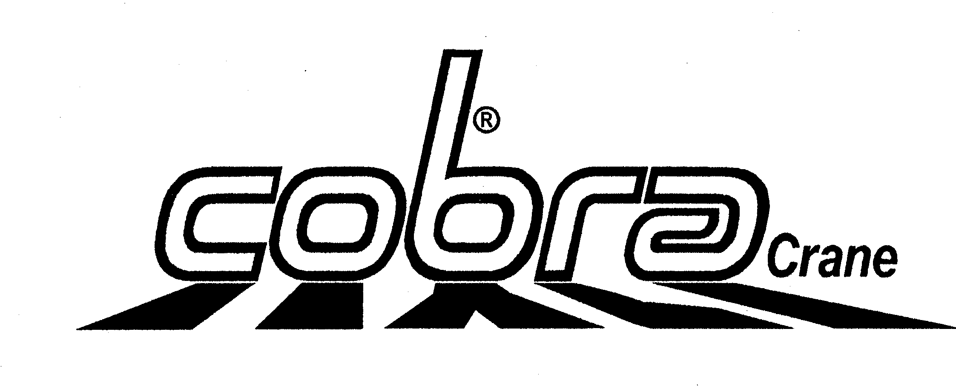
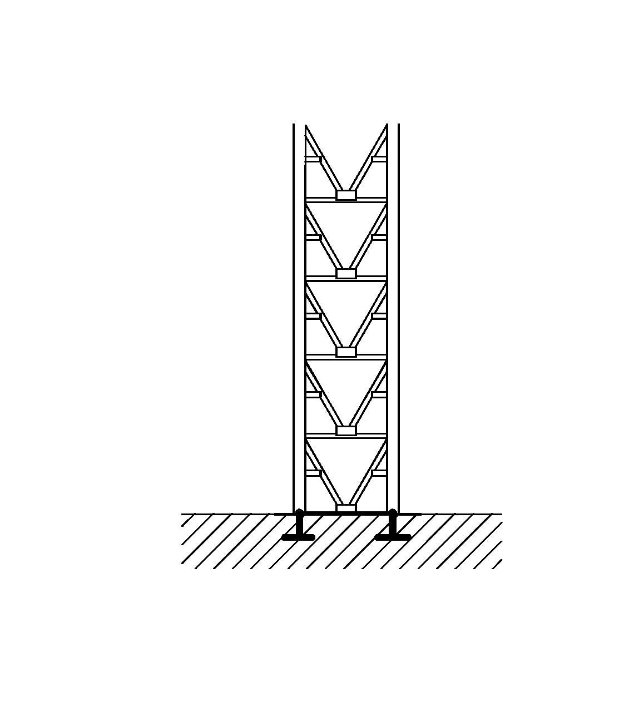
1,6 m
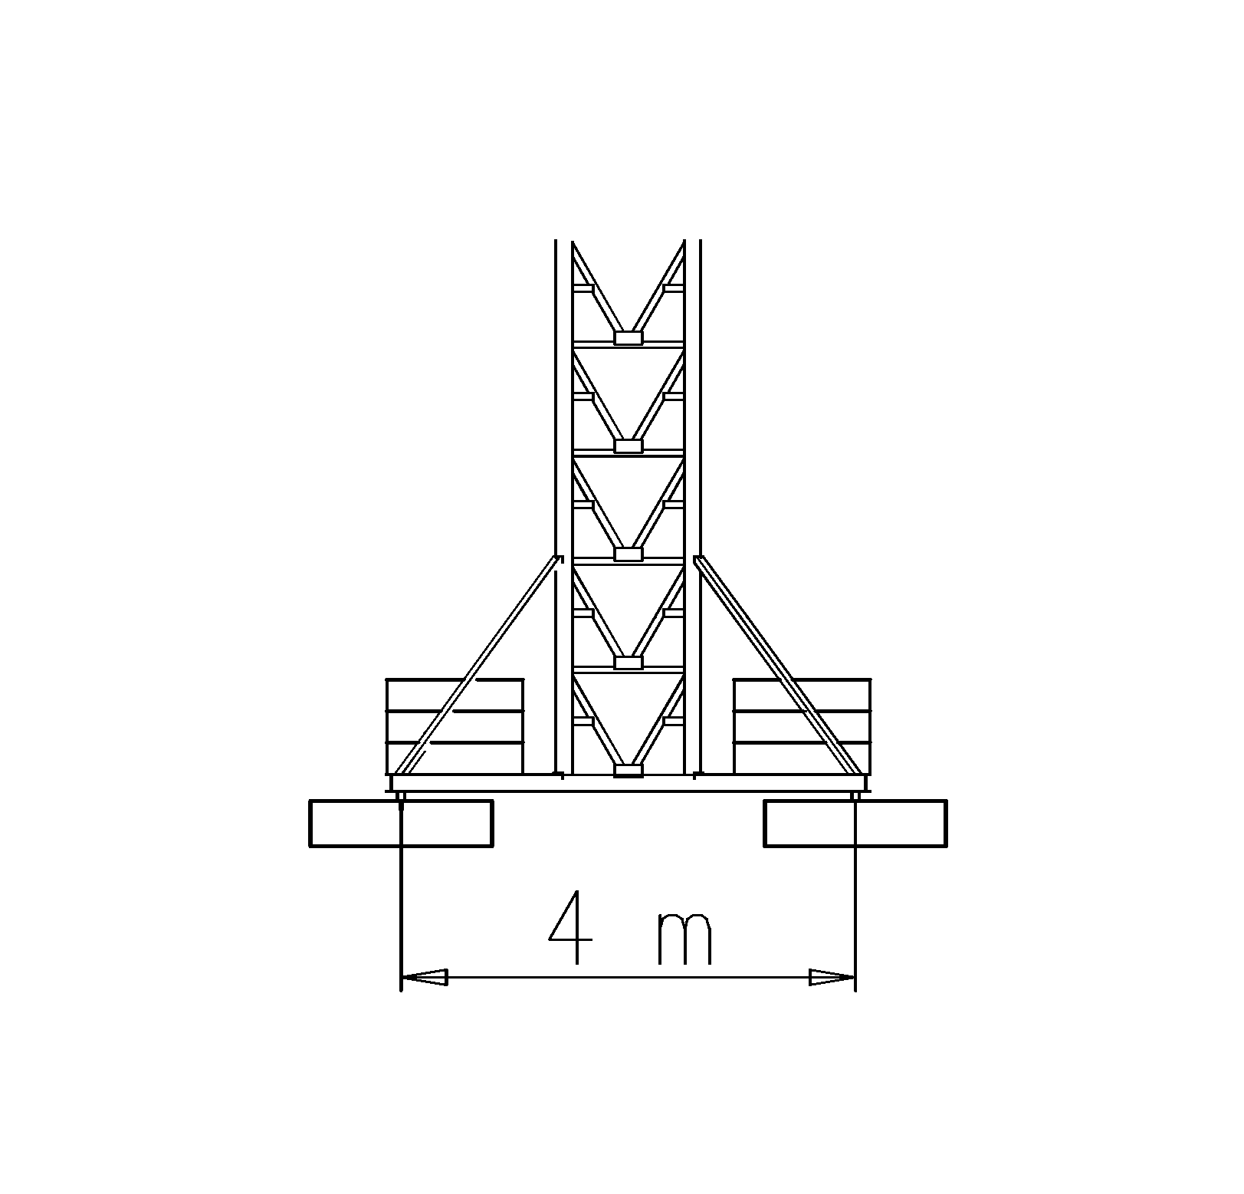
Rte du Pré-Seigneur
1564 Domdidier-CH

Tel: +41 (0) 26 675 41 34
Fax: +41 (0) 26 675 41 35
Mail: cobra-crane@bluewin.ch

 |  |  | Ref. data 406
Sous réserves de modifications | Konstruktionsänderungen vorbehalten |  | Subject to alterations
538 Patent pending
* En option / Option / Option
Yerly Jean-Marc SA
Rte du Pré-Seigneur
1564 Domdidier-CH

Tel: +41 (0) 26 675 41 34
Fax: +41 (0) 26 675 41 35
Mail: cobra-crane@bluewin.ch
www.cobra-crane.com
5 m
4 m

