Flèche articulée |  |  | Knickausleger | Articulated jib
Flèche relevable* |  | Wippausleger* | Luftable jib*
* En option / Option / Option

H

2 m - 20 m 12 t
50 m 4.5 t
H

8 m - 20 m 7 t
50 m 3 t

Courbe de charge |  |  | Lastkurve | Load diagram
Châssis de base |  |  | Unterwagen | Basic chassis

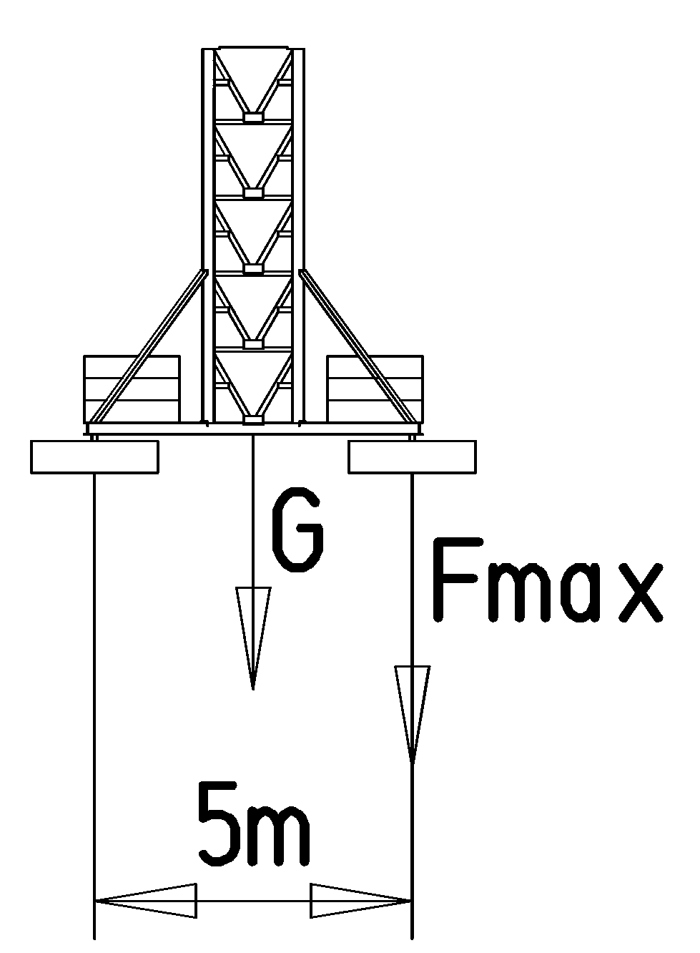 | H (m) | 19 | 25 | 31 | 37* | 43* | 49*
 |  | 46+20 | 46+20 | 46+20 | 49+20 | 70+20 | 100+20
 | G (t) | 147.9 | 150.4 | 153.0 | 158.6 | 182.2 | 214.8
 | F max (t) | 88 | 91 | 93 | 98 | 119 | 142
m | 2 | ► | 20 | 22 | 24 | 26 | 28 | 30 | 32 | 34 | 36 | 38 | 40 | 42 | 44 | 47 | 50
t | 100% |  | 10 | 8.5 | 7.5 | 6.8 | 6.5 | 6.2 | 5.9 | 5.6 | 5.4 | 5.1 | 4.9 | 4.6 | 4.4 | 4.0 | 3.8
 | 120% |  | 12 | 10.3 | 9.1 | 8.2 | 7.8 | 7.5 | 7.1 | 6.8 | 6.5 | 6.2 | 5.9 | 5.6 | 5.3 | 4.8 | 4.5
(t)
1

Conditions de fonctionnement différentes / Abweichende Betriebsbedingungen / Variant service conditions
1

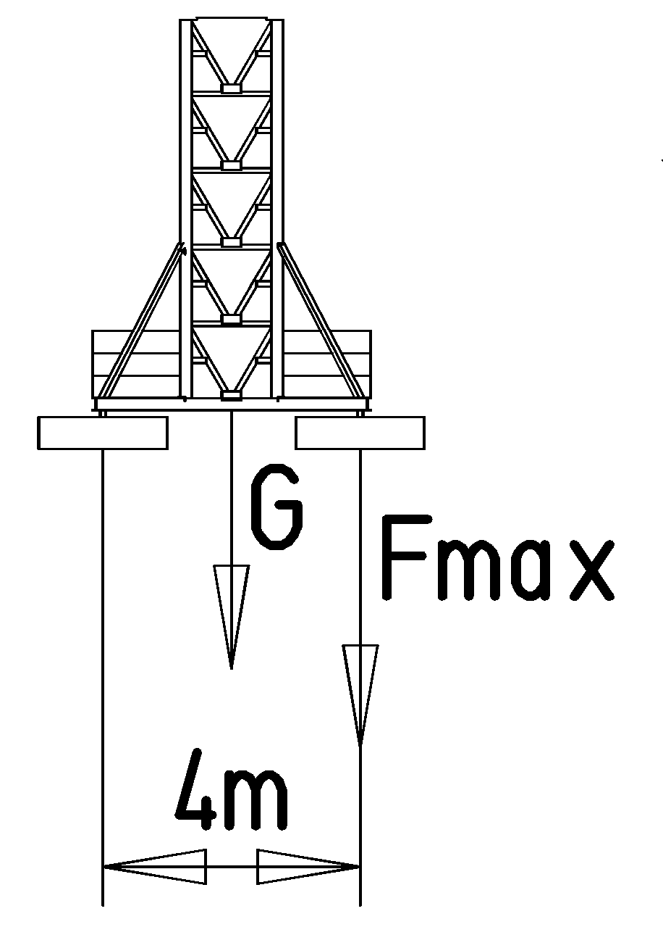 | H (m) | 19 | 25 | 31 | 37*
 |  | 78+20 | 79+20 | 80+20 | 82+20
 | G (t) | 179.9 | 183.5 | 187.0 | 191.6
 | F max (t) | 111 | 113 | 116 | 122

t
(t)
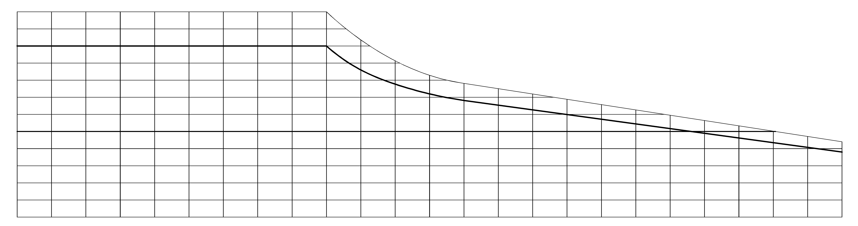

12

10
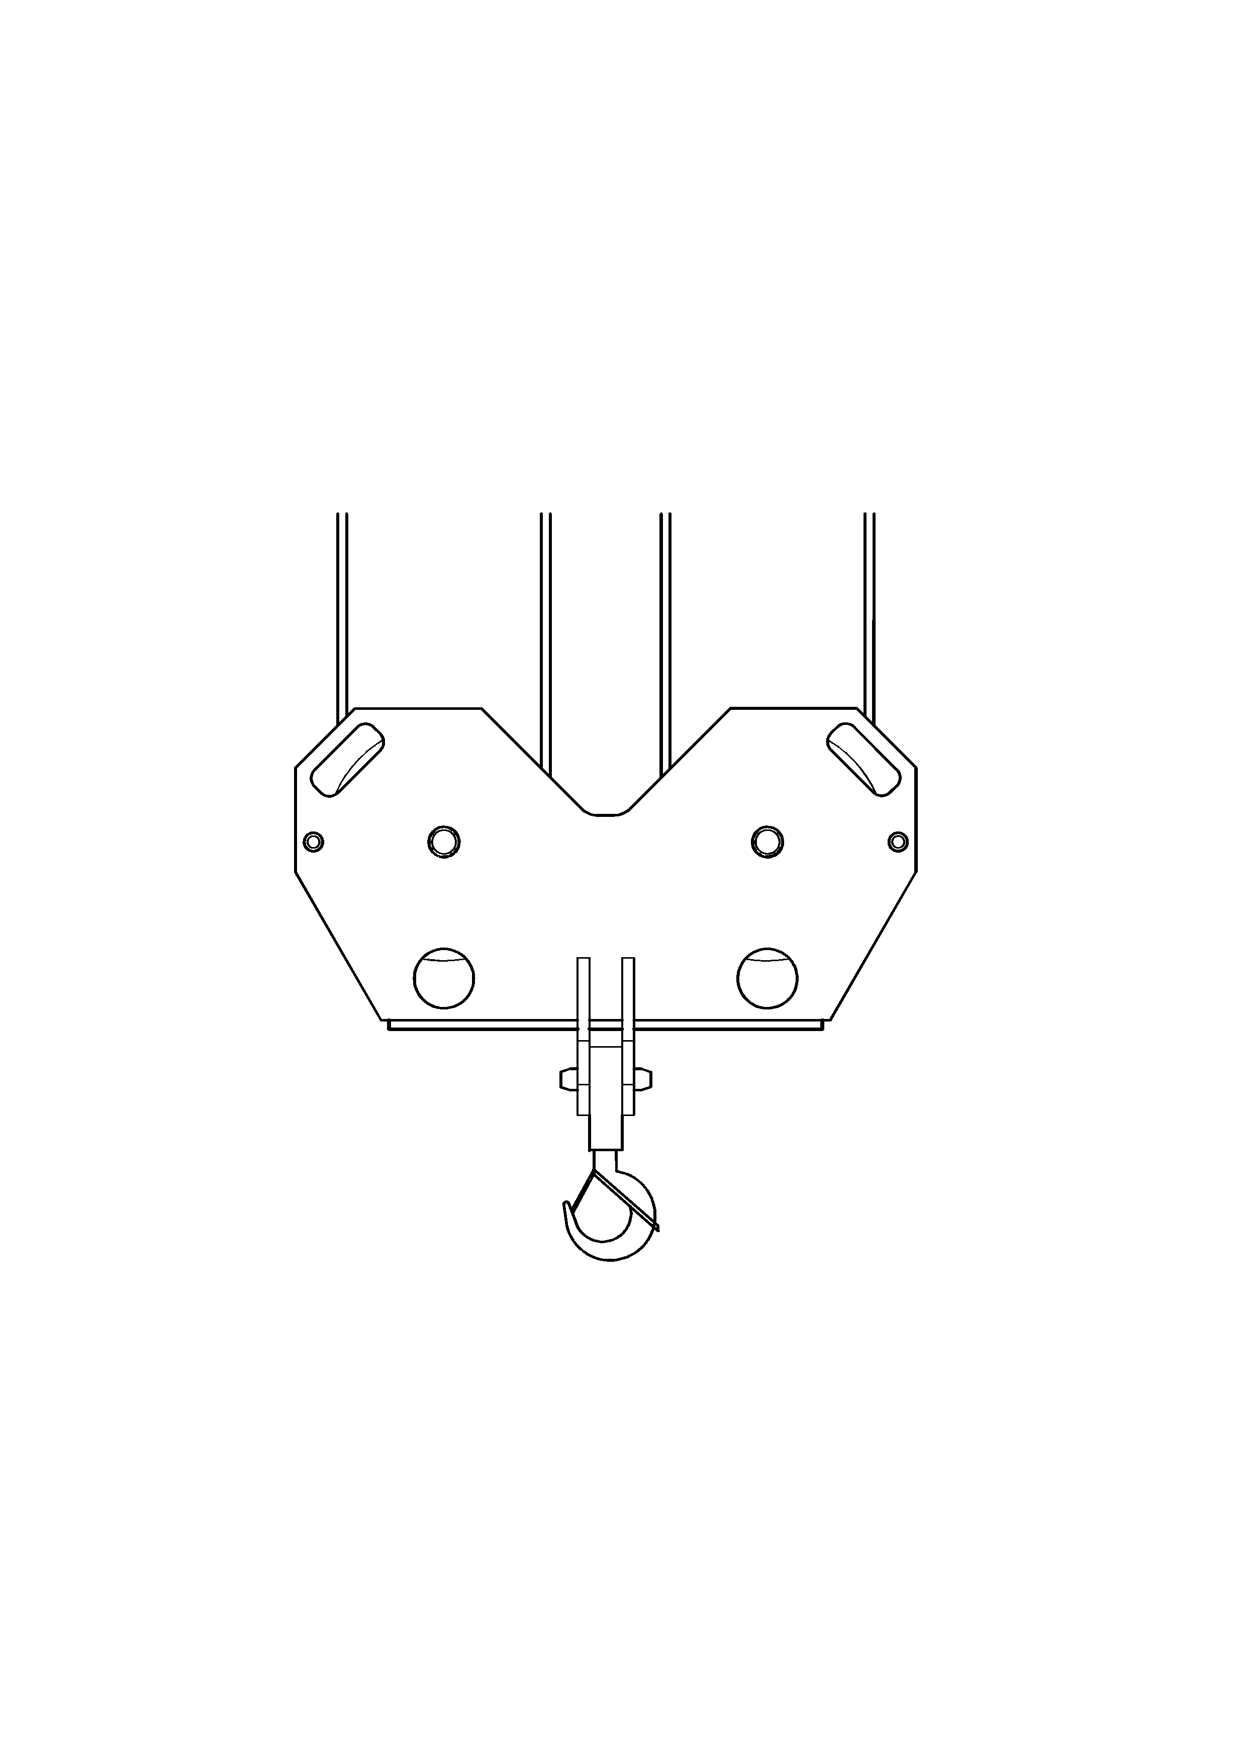
8
6
* Nous consulter / Auf Anfrage / Consult us
H: Hauteur sous cabine / Kabinenhöhe / Height under cabin
: Lest de base / Grundballast / Base ballast
G: Poids total / Totalgewicht / Total weight
F max: Réaction / Eckdruck / Reaction

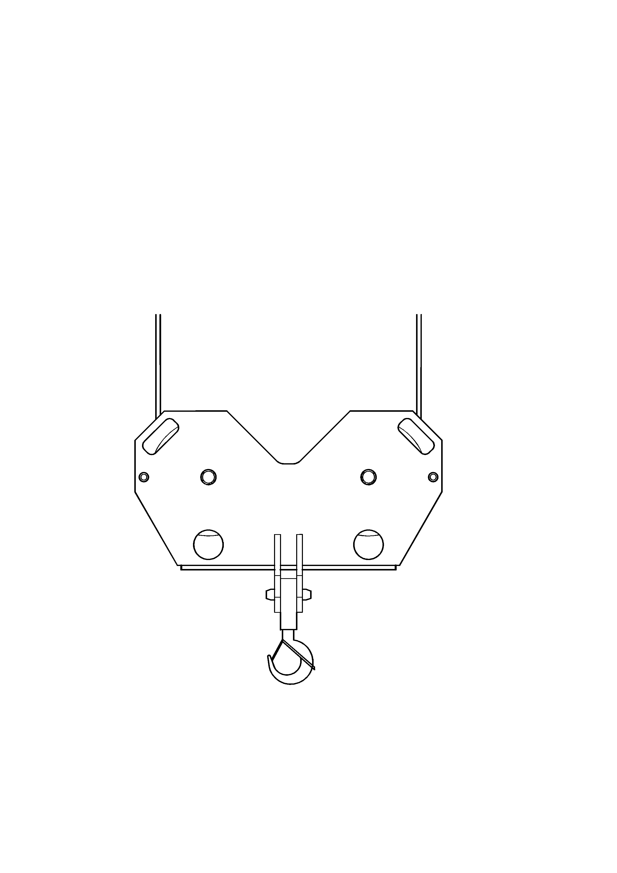

4
2
10
30
40
50 m
2

20

538 Patent pending | 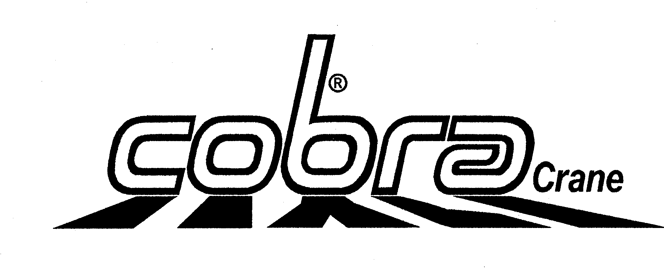
538 Patent pending

