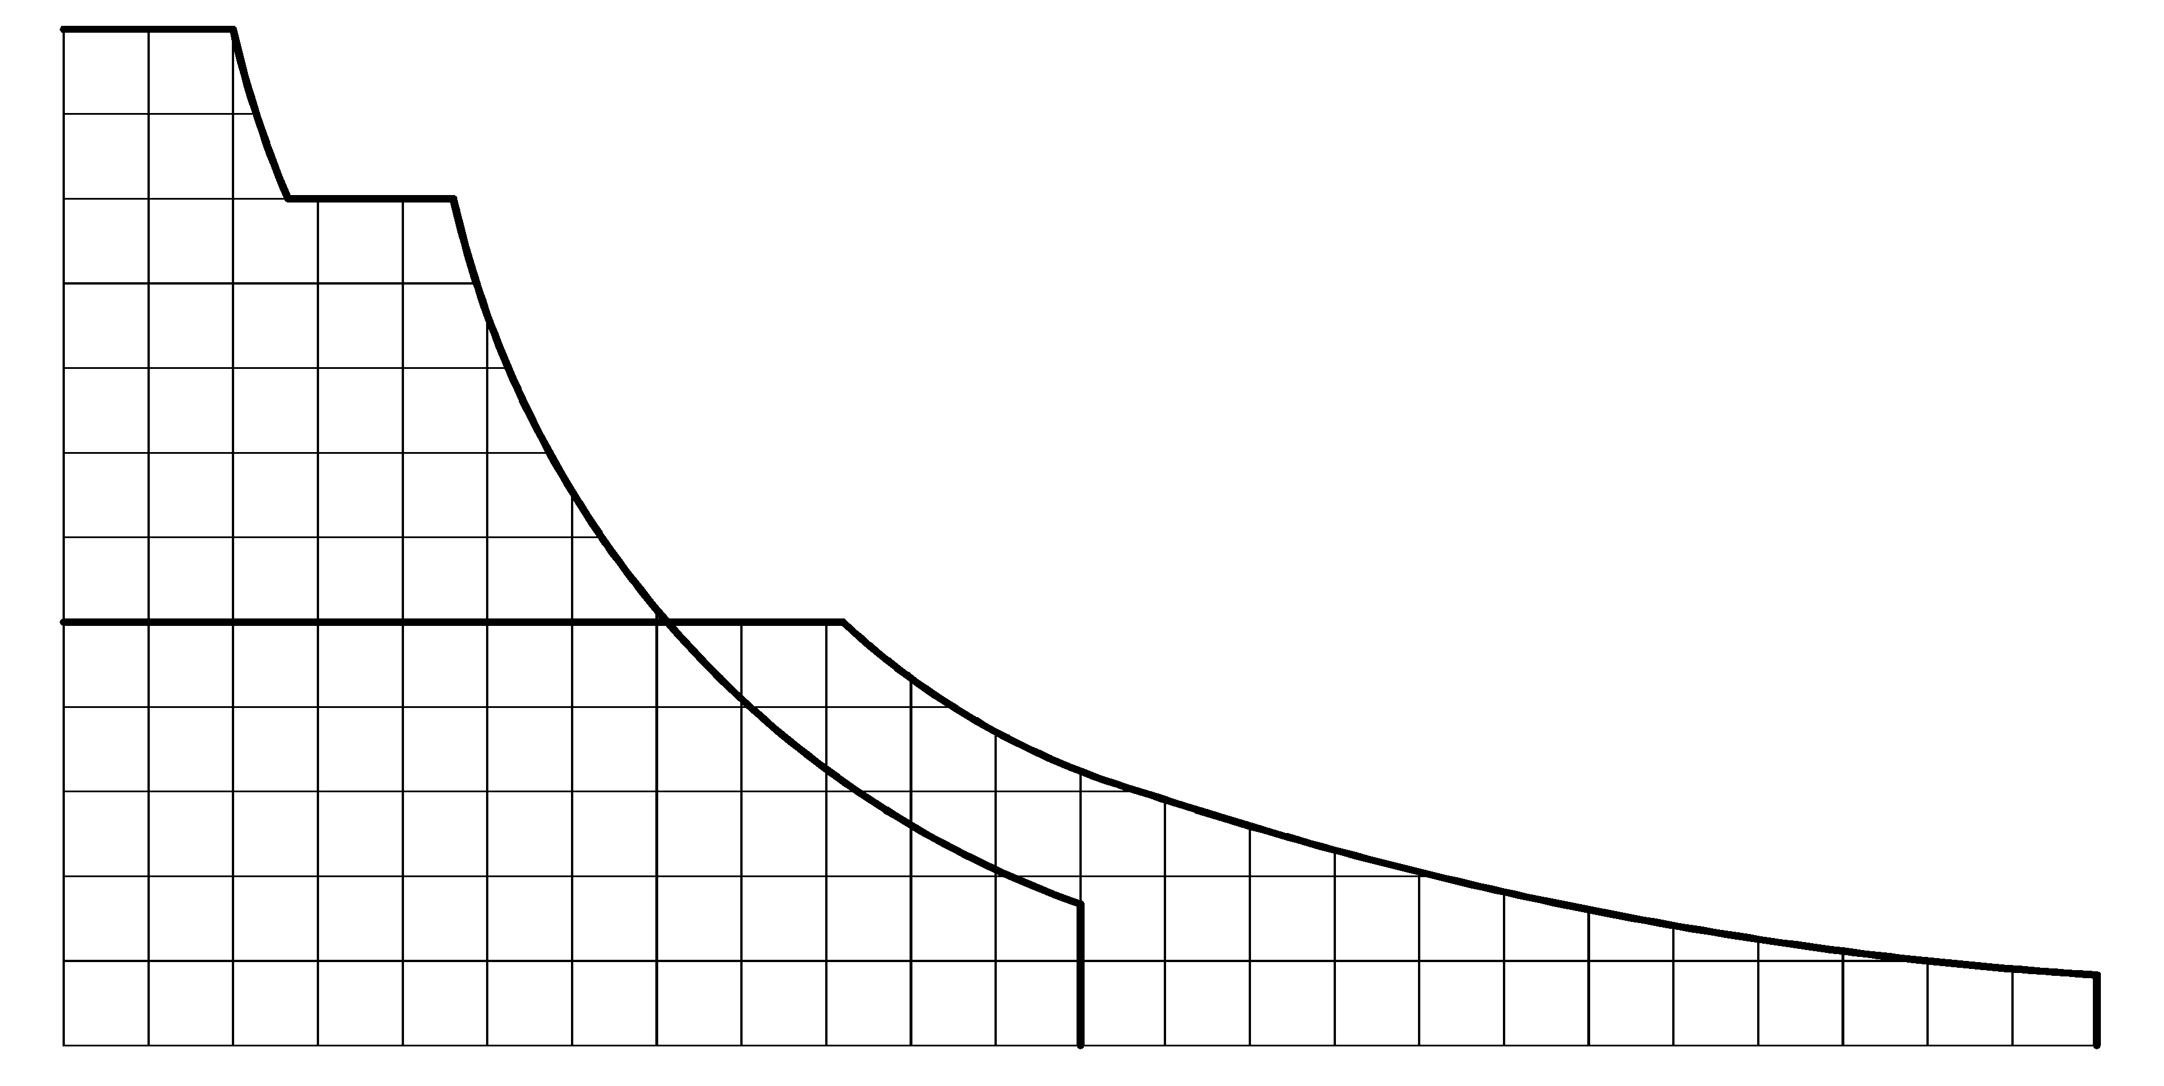
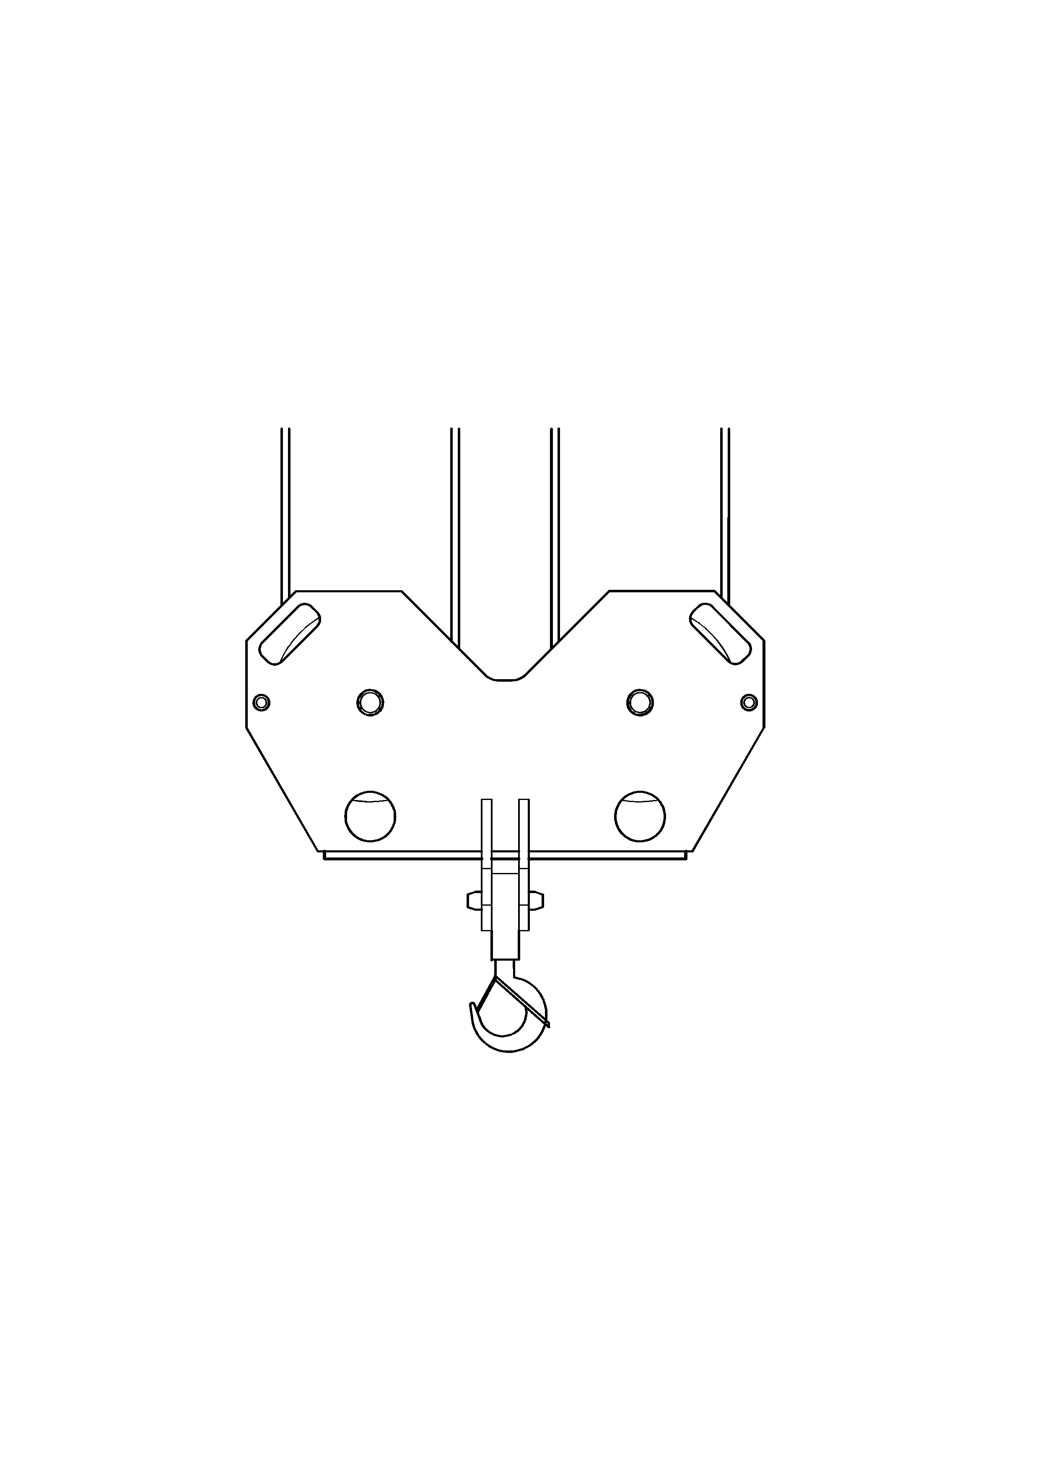
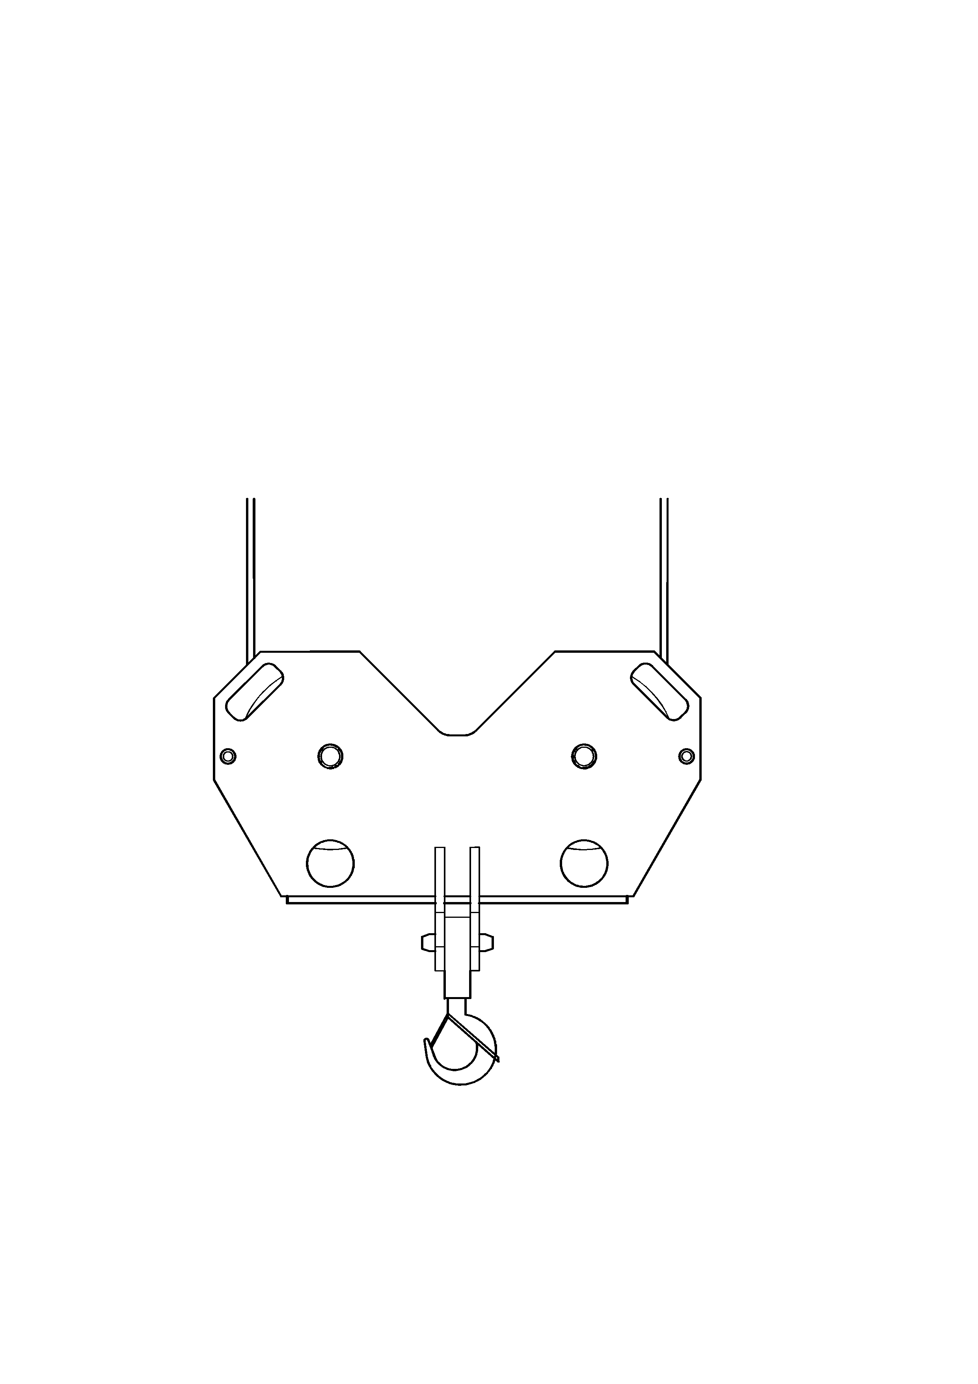
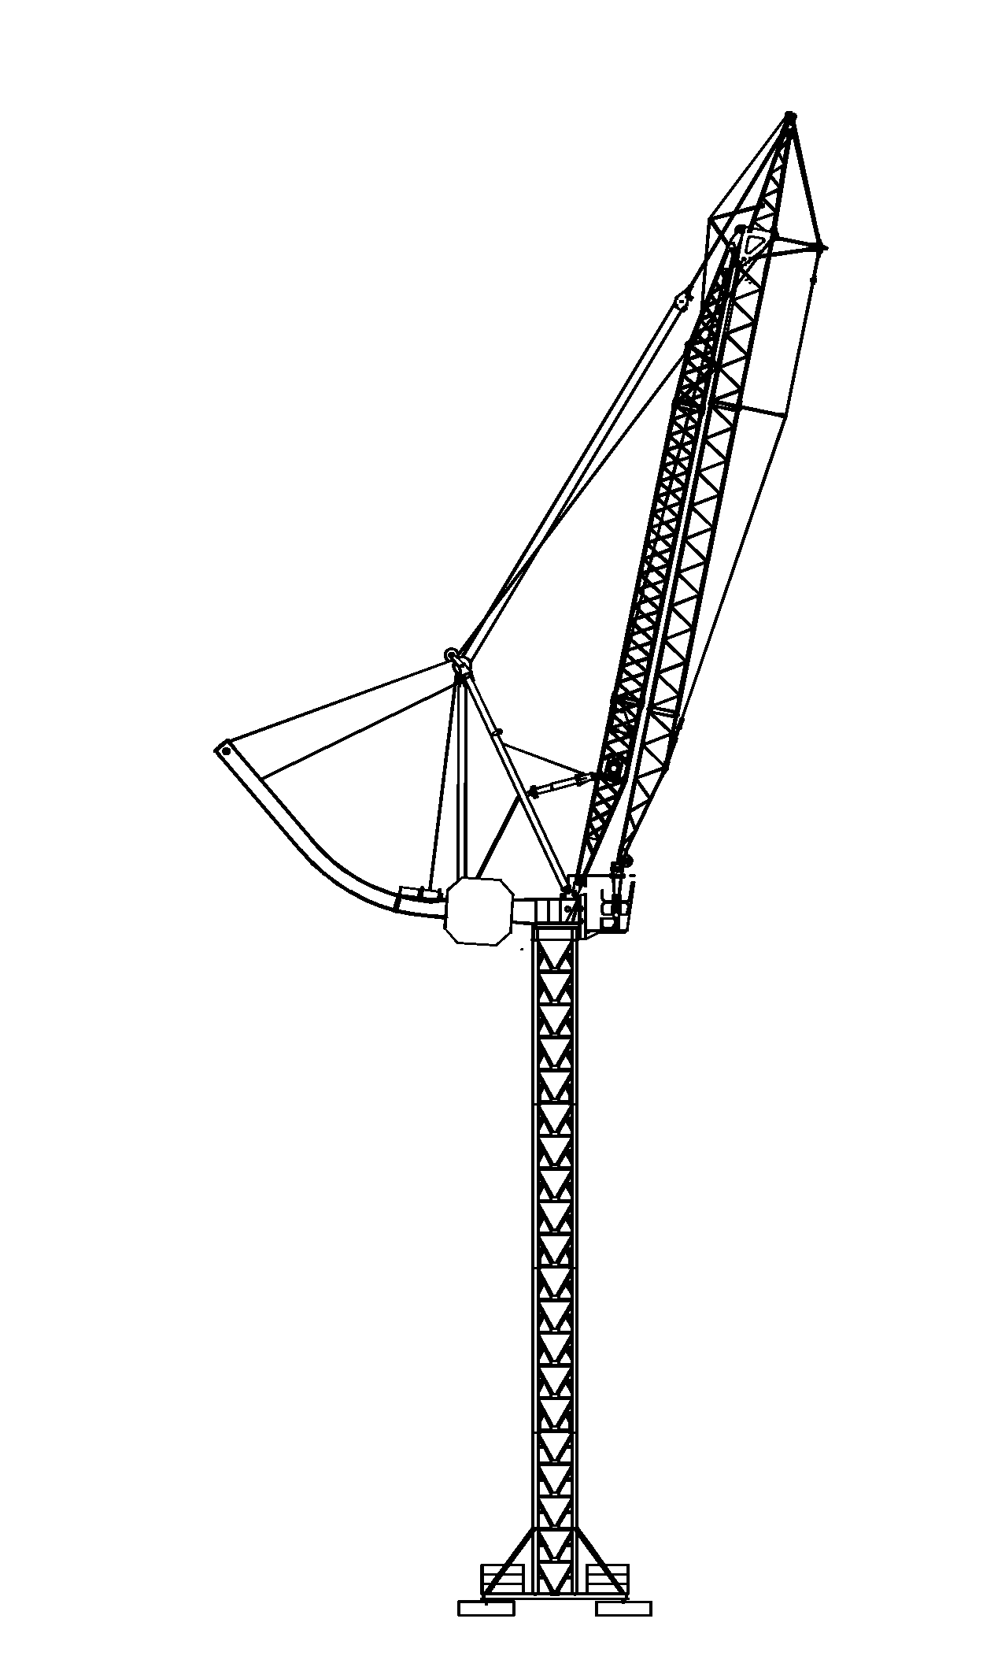
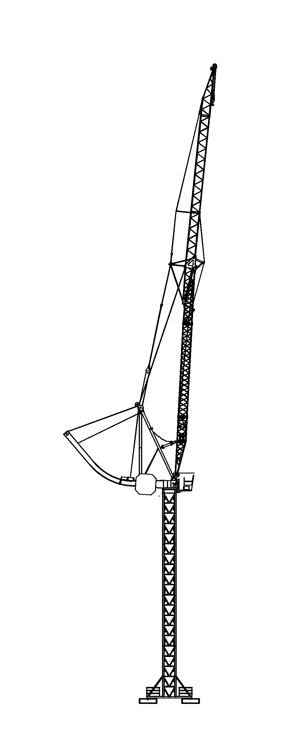
Mécanismes |  |  |  | Antriebe |  |  |  | Mechanismus
Distribution  Verteilung  Distribuation | Relevage  Armheben  Jib hoisting |  | Rotation  Schwenken  Slewing |  |  |  |  |  | Heben |  |  | Hoisting
0-100 m/min | 0-17 m/min |  | 0-1.5 tr/min
0-100 m/min |  |  |  |  | 45 kW | Puissance requise  Anschlusswert  Power requirement |  |  |  |  | 94 kVA 135 A |  | 400 V – 50 Hz
(2) 7.5 kW | 22 kW |  | 7.5 kW |  | 45 kW |  |  |  |  |  | 115 kVA 165 A* |  | 400 V – 50 Hz
Grue à tour à flèche articulée et relevable*
Turmdrehkran mit Knick- und Wippausleger*
Tower Crane with articulated and liftable jib*

Cobra 638
Patent pending
Levage
40
4 plots de base, 20 t au total, non compris
60
80
1000
120
m/min
2
4
6
8
10
t
12

Exemple de  transport |  |  |  | Transportbeispiel |  |  |  |  |  | Example of  transport

Hauteur sous crochet / Lasthakenhöhe / Height under hook 31 m

Châssis de base / Unterwagen / Basic chassis 5x5
 |  |  |  |  |  | Pos. | Qte. | L(m) | B(m) |  | H(m) | t
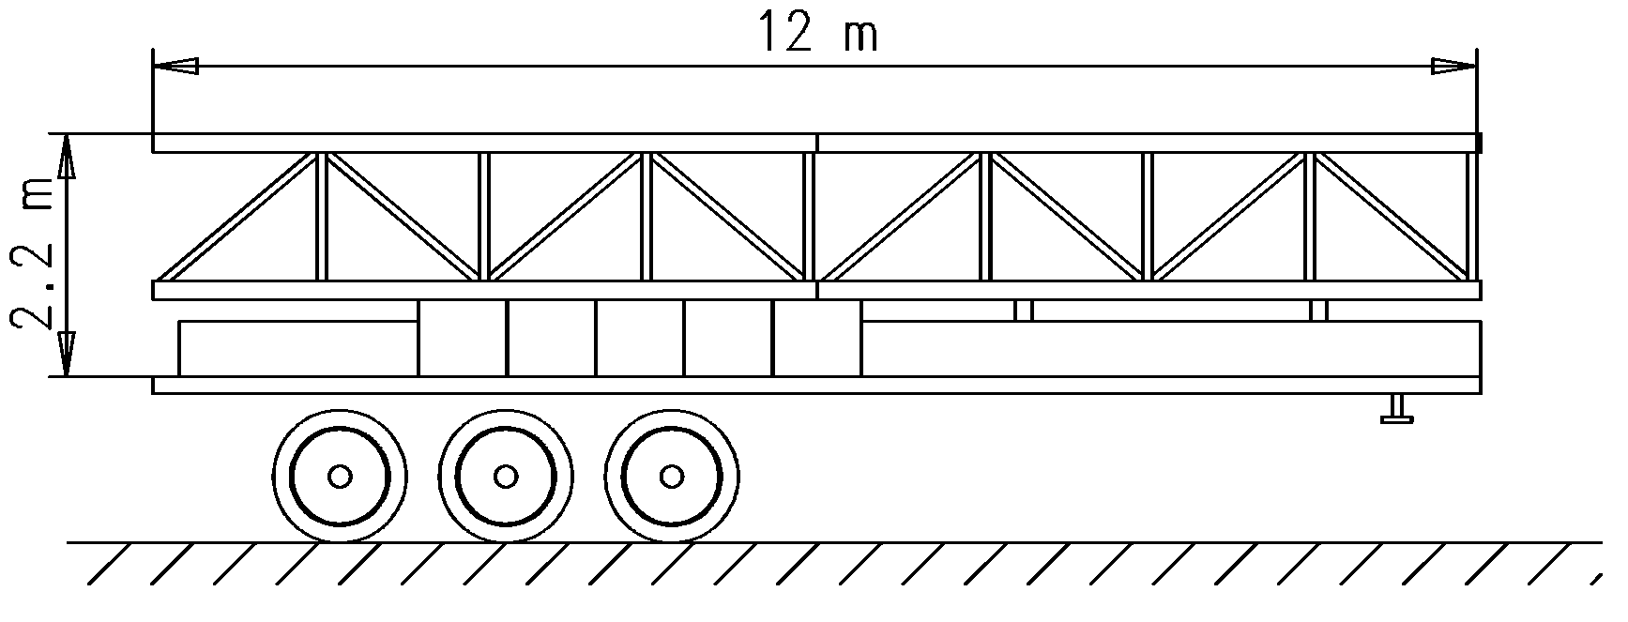  10  6  8  7 |  |  |  |  |  | 6 | 2 | 6.00 | 1.50 |  | 1.50 | 2 x 2.58
 |  |  |  |  |  | 7 | 1 | 5.60 | 2.16 |  | 0.50 | 0.40
 |  |  |  |  |  | 8 | 1 | 2.40 | 2.16 |  | 0.50 | 0.75
 |  |  |  |  |  | 10 | 5 | 2.40 | 0.80 |  | 0.70 | 5 x 3.30
 |  |  |  |  |  |  |  |  |  |  |  | 22.81
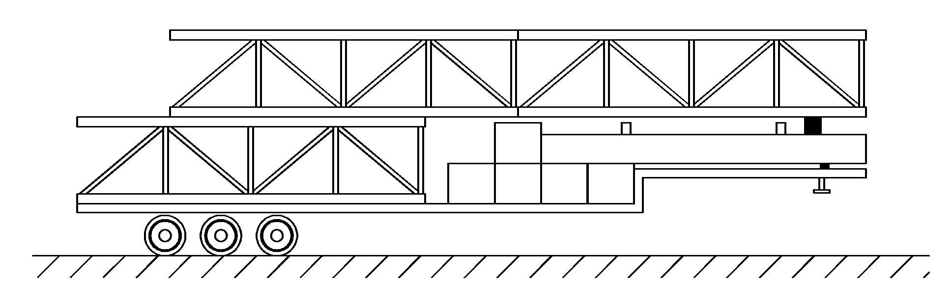  6  7  10 |  |  |  |  |  | 6 | 3 | 6.00 | 1.50 |  | 1.50 | 3 x 2.58
 |  |  |  |  |  | 7 | 1 | 5.60 | 2.16 |  | 0.50 | 0.40
 |  |  |  |  |  | 10 | 5 | 2.40 | 0.80 |  | 0.70 | 5 x 3.30
 |  |  |  |  |  |  |  |  |  |  |  | 24.64
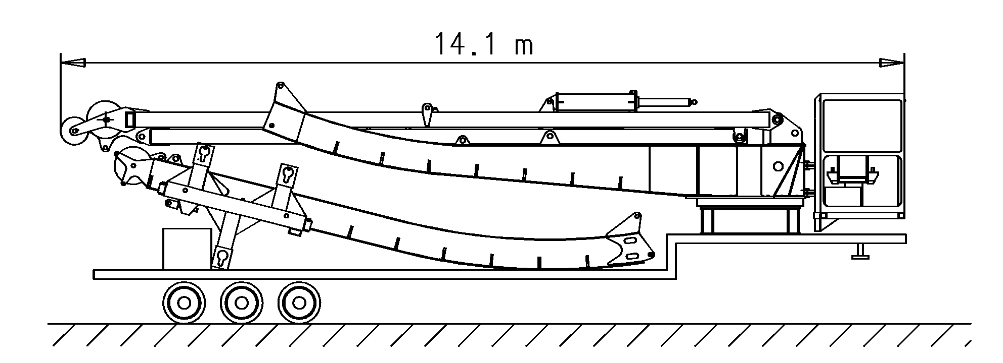  4  5  10 |  |  |  |  |  | 4 | 1 | 14.10 | 2.45 |  | 2.37 | 16.00
 |  |  |  |  |  | 5 | 1 | 9.00 | 2.35 |  | 2.10 | 5.80
 |  |  |  |  |  | 10 | 1 | 2.40 | 0.80 |  | 0.70 | 3.30
 |  |  |  |  |  |  |  |  |  |  |  | 25.10
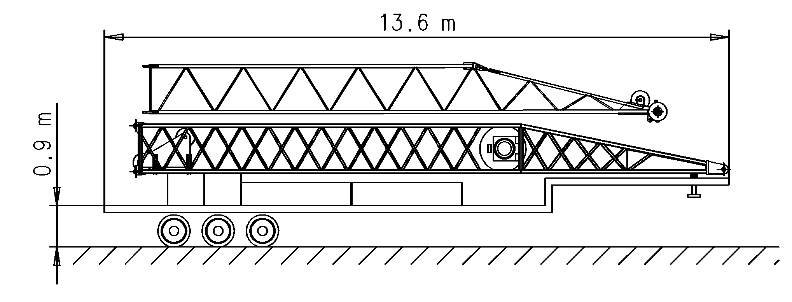  9  10 |  |  |  |  |  | 1 | 1 | 12.80 | 2.30 |  | 2.44 | 6.65
 |  |  |  |  |  | 9 | 2 | 2.40 | 2.40 |  | 0.50 | 2 x 6.30
 |  |  |  |  |  | 10 | 2 | 2.40 | 0.80 |  | 0.70 | 2 x 3.30
 |  |  |  |  |  |  |  |  |  |  |  | 25.85
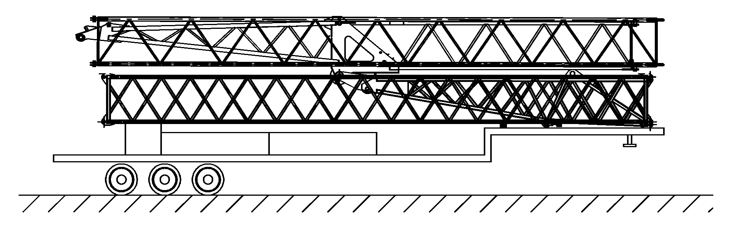  2  3  9  10 |  |  |  |  |  | 2 | 1 | 12.61 | 1.10 |  | 2.39 | 2.47
 |  |  |  |  |  | 3 | 1 | 12.84 | 1.20 |  | 2.48 | 4.90
 |  |  |  |  |  | 9 | 2 | 2.40 | 2.40 |  | 0.60 | 2 x 6.50
 |  |  |  |  |  | 10 | 1 | 2.40 | 0.80 |  | 0.70 | 3.30
 |  |  |  |  |  |  |  |  |  |  |  | 23.67
Poids total |  |  |  |  | Totalgewicht |  |  |  | Total weight |  |  | 122.10 t
1
2
3
1
4
5

12 t
4,5 t
60 m
2 m
22 m
14.9 m
31 m

43,1 m
ϲε FEM 1.001-A3

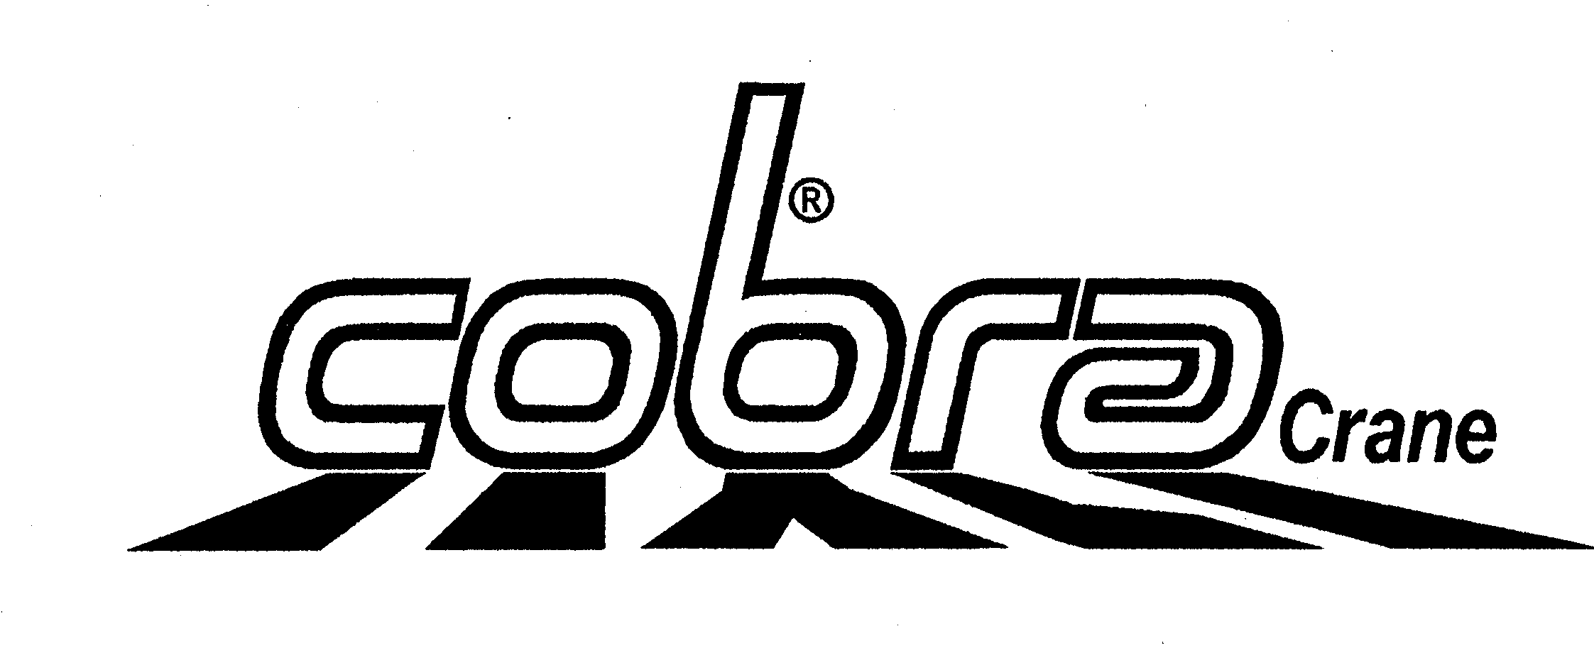
1,6 m
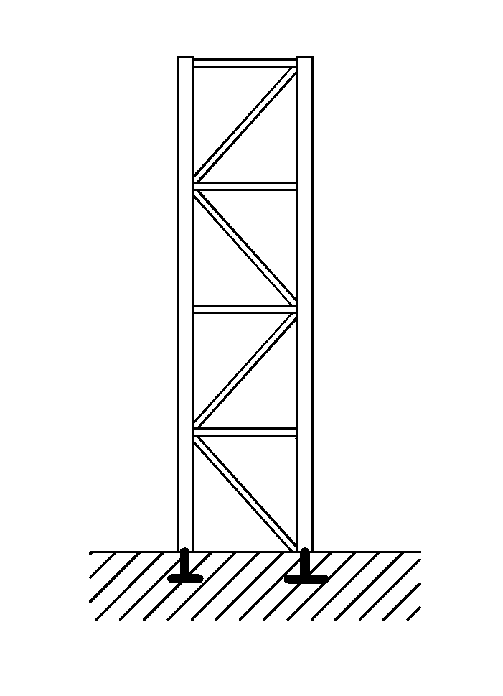
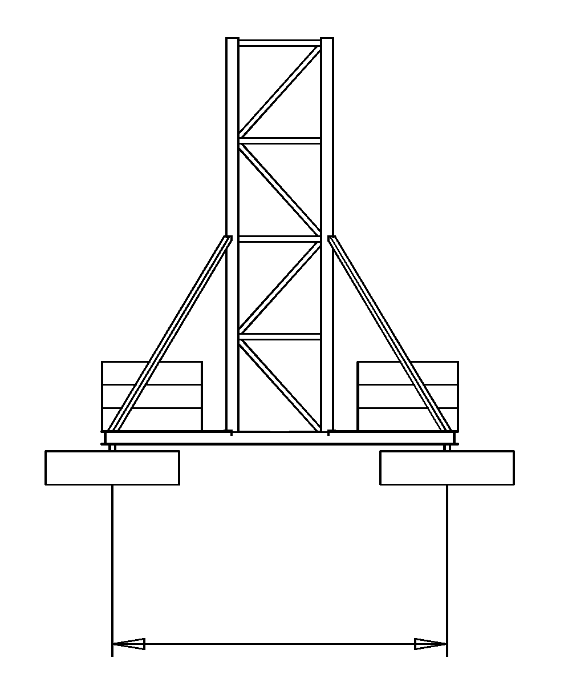
Rte du Pré-Seigneur
1564 Domdidier-CH

Tel: +41 (0) 26 675 41 34
Fax: +41 (0) 26 675 41 35
Mail: cobra-crane@bluewin.ch

 |  |  | Ref. data 506
Sous réserves de modifications | Konstruktionsänderungen vorbehalten |  | Subject to alterations
638 Patent pending
Yerly Jean-Marc SA
Rte du Pré-Seigneur
1564 Domdidier-CH

Tel: +41 (0) 26 675 41 34
Fax: +41 (0) 26 675 41 35
Mail: cobra-crane@bluewin.ch
www.cobra-crane.com
5 m
4 m
4 plots de base, 20 t au total, non compris
12

